Digital RF Technology, Inc. (DRFT) has been in the process of creating the highest resolution, full range scale, weather radar display system to date. The software, known as SKYSWEEPTM, has been in development for the last four years with the main broadcast test facility located at KWTV-9 in Oklahoma City, Oklahoma.

COMPETITIVE ADVANTAGE
HIGHEST RESOLUTION DATA

The SKYSWEEPTM system generates the highest resolution data when operating at full radar range than any other product available on the market today. Because data resolution is a function of sample rate, the more often a sample is taken the better the processed image will appear. In turn, this will provide the meteorologist with more accurate information for use in determining the most severe area of a thunderstorm. By implementing special processes in computer software code combined with high-end computer technology, DRFT’s SKYSWEEPTM system is capable of sampling radar intensity data every 150 meters in range and every 0.08 degrees in azimuth while operating through the radar’s full range. If operating in Doppler mode, the specifications remain unchanged, and the effective range is reduced to approximately 75 miles depending on the pulse rate of the particular radar. The radar images produced by SKYSWEEPTM will give the meteorologist a major competitive advantage when warning the viewing audience of threats such as tornadoes or other severe weather. In addition, no smoothing processes are required so the data integrity remains at the highest possible level. Selectable range integration is provided to enhance the display on long (>125 miles) scales when detailed analysis is not required.

Competing products operating at full intensity range, typically 250 miles, only sample data every 1 kilometer. As the radar dish turns these products sample the data every 1-degree in azimuth. The result is an image that has a “blocky” appearance when zooming in closer and closer on a particular storm. To minimize this appearance, steps are taken to smooth the data into a form which makes it more appealing to the viewing audience. Unfortunately, once any smoothing has been applied, the integrity of the underlying data is lost, and the meteorologist must rely more on preprogrammed algorithms to determine threat areas. Even if smoothing does not take place, the 1-kilometer by 1-degree resolution makes it very difficult to analyze a severe storm.

Below is a comparison of a NEXRAD image and the SKYSWEEPTM system
during the May 9, 2003 tornado in Oklahoma City, OK.

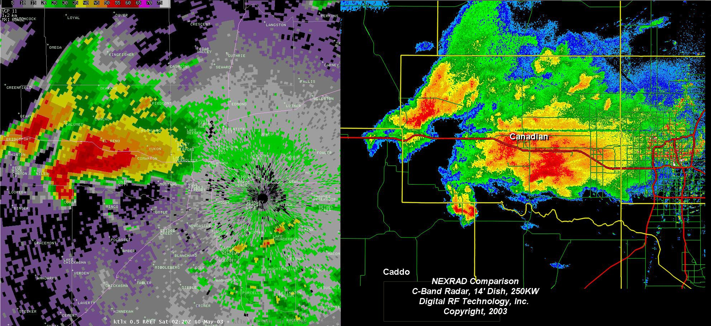

MULTIPLE DISPLAY MONITORS

Another key advantage of SKYSWEEPTM is the ability to view simultaneous Doppler and intensity radar data on separate monitors. Each display position has two monitors that can be configured “on-the-fly” depending on the user’s needs. For example, one monitor can display Doppler data while the other displays intensity data, or the user may view intensity data on each monitor or Doppler data on each monitor. These changes can be made with a simple click of the mouse. The user also has the capability to independently pan or zoom one monitor without altering the appearance of the other monitor. This is a very powerful tool when analyzing two storm cells located in different parts of the DMA.

MULTIPLE DISPLAY POSITIONS

The SKYSWEEPTM system has a third key advantage over other competitors in the ability to have more than one display position connected to a radar unit. Although a typical installation would be comprised of a position located “on-set” and the other located “off-set”, the software allows the second position to be located anywhere a T1 telco circuit or LAN connection is available. With two positions and their associated monitors, the meteorology staff has four times the viewing capability. The second position operates independently of the first, allowing four different storm locations, county/state views, etc. to be at the station’s disposal simultaneously. The system has been designed to accommodate as many display positions as possible and is only limited to the number of physical LAN or T1 connections. During the May 9, 2003 tornado in Oklahoma City, OK, a total of three display computers were connected to the same radar unit without any system degradation.

DATA ARCHIVING

The SKYSWEEPTM system has been designed to archive any radar data the user desires. During a weather event the user simply initiates an archive command and the data will be saved to the computer’s hard disk. After the event has passed, the file can be transferred to a DVD drive located on each display computer. The most important characteristic of this data is the fact that it is recorded in raw radial form. Unlike other systems that save only the radar screen images, the SKYSWEEPTM system archive process ensures the actual radar data integrity is maintained. These saved sessions can be replayed at a later date and will be displayed on the computer screens as if the radar itself was sending information. The user can pan, zoom, stop or rewind the data as desired. This is an especially powerful tool for creating promotional material, training new talent or analyzing past severe weather events.

COMPONENTS

• Street Level Mapping

• Storm Track and Time of Arrival

• Radar Control

• HDTV Ready

• Website Image Upload

real world testing

The first television station to put the SKYSWEEPTM system to the test was KWTV-9 in Oklahoma City, OK. This location was chosen for two critical reasons: 1) Oklahoma has some of the most severe weather in the United States and 2) the meteorological staff has the experience necessary to analyze the most challenging storms. Chief Meteorologist Gary England has been on the air at KWTV for over 30 years and is an expert on severe weather. When he saw first-hand how the SKYSWEEPTM system performed during a tornado outbreak on May 9, 2003, his response was simple and to the point:

“It was the most incredible radar presentation I had ever seen.”
Gary England, KWTV-9

NBC5 in Dallas/Ft. Forth, TX was the second station in the United States to benefit from the SKYSWEEPTM system. DRFT acted as general contractor on their new 1MW radar project and integrated the SKYSWEEPTM system to maximize their capital investment. This combination of high resolution and high power has given NBC5 a distinct competitive advantage in the marketplace.

If you would like an on-site demonstration to see first-hand how the SKYSWEEPTM system can set your station apart from the competition, please contact us at 903.872.6554.

